Certificate of Service

This certificate is presented to

In Appreciation for years of Faithful and
Meritorious Service to the

Our best wishes and heartfelt thanks accompany
this expression of gratitude.

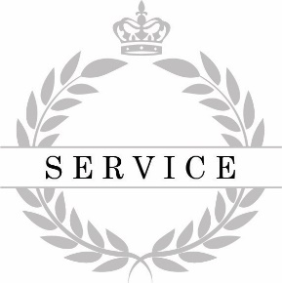
Dated:

