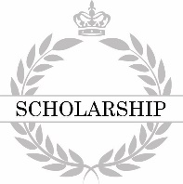
Salutatorian Award

is awarded this certificate for achieving
High Honors in Scholarship
at

This honor is conferred this day of

